04. Path

- Give a binary tree, find if it's possible to cut the tree into two halves of equal sum. You can only cut one edge.

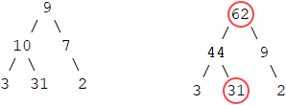

int getSum(Node *node)
{
if (node == NULL)
{
return 0;
}

return getSum(node->left) + getSum(node->right) + node->data;
}

bool checkNode(Node *node, int half)
{
if (node == NULL)
{
return false;
}

if (getSum(node) == half)
{
return true;
}

return checkNode(node->left, half) || checkNode(node->right, half);
}

bool checkTree(Node *root)
{
int total = getSum(root);
if (total % 2 == 1)
{
return false;
}

return checkNode(root, total / 2);
}

You can also use stack to improve performance.

stack<int> s;

int getSum(Node *node)
{
if (node == NULL)
{
return 0;
}

int sum = getSum(node->left) + getSum(node->right) + node->data;
s.push(sum);

return sum;
}

bool checkTree(Node *root)
{
int total = getSum(root);
if (total % 2 == 1)
{
return false;
}

while (!s.empty())
{
if (s.top() == total / 2)
{
return true;
}

s.pop();
}

return false;
}

The following shows if the tree nodes do not have weights.

int getSum(Node *node)
{
if (node == NULL)
{
return 0;
}

return getSum(node->left) + getSum(node->right) + 1;
}

- Flatten a binary tree into a linked list.

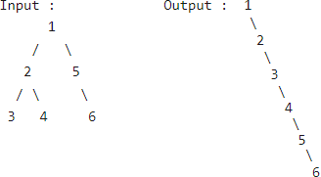

void flatten(Node *node)
{
if (node == NULL)
{
return;
}

flatten(node->left);
flatten(node->right);

if (node->left != NULL)
{
Node *n = node->left;
while (n->right != NULL)
{
n = n->right;
}

n->right = node->right;
node->right = node->left;
node->left = NULL;
}
}

- In a binary tree, connect the nodes at same Level.

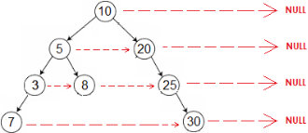

// get the next right of the child node of the given node, e.g. 5 -> 25, 3 -> 30
Node *getNextRight(Node *node)
{
Node *temp = node->nextRight;

while (temp != NULL)
{
if (temp->left != NULL)
{
return temp->left;
}

if (temp->right != NULL)
{
return temp->right;
}

temp = temp->nextRight;
}

return NULL;
}

void connect(Node* node)
{
if (node == NULL)
{
return;
}

if (node->right)
{
node->right->nextRight = getNextRight(node);
connect(node->right);
}

if (node->left)
{
if (node->right)
{
node->left->nextRight = node->right;
}
else
{
node->left->nextRight = getNextRight(node);
}

connect(node->left);
}
}

The following uses a queue.

void connect(Node* root)
{
queue<Node*> q;
q.push(root);
q.push(NULL);

while (!q.empty())
{
Node *p = q.front();
q.pop();

if (p != NULL)
{
p->nextRight = q.front();

if (p->left != NULL)
{
q.push(p->left);
}

if (p->right != NULL)
{
q.push(p->right);
}
}
else if (!q.empty())
{
q.push(NULL); // push NULL to mark the end of current level
}
}
}

- Serialize and deserialize a binary tree so that it can be stored and fetched from a file.

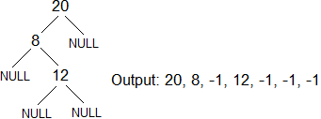

#define MARKER -1

void serialize(Node *node, FILE *fp)
{
if (node == NULL)
{
fprintf(fp, "%d ", MARKER);
return;
}

fprintf(fp, "%d ", node->data);

serialize(node->left, fp);
serialize(node->right, fp);
}

Node *deserialize(FILE *fp)
{
int val;
if (!fscanf(fp, "%d ", &val) || val == MARKER)
{
return NULL;
}

Node *node= new Node(val);

node->left = deserialize(fp);
node->right = deserialize(fp);

return node;
}

void test(Node *root)
{
FILE *fp = fopen("file1.txt", "w");
serialize(root, fp);
fclose(fp);

fp = fopen("file2.txt", "r");
root = deserialize(fp);
fclose(fp);
}

- Find the diameter of a binary tree. The diameter of a binary tree is also called the width of the binary tree. It is the number of nodes on the longest path between two end nodes.

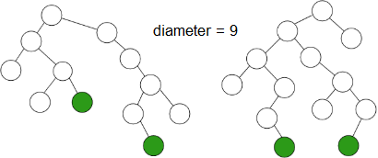

int height(Node* node)
{
if (node == NULL)
{
return -1;
}

return max(height(node->left), height(node->right)) + 1;
}

int diameter(Node * node)
{
if (node == NULL)
{
return 0;
}

int hl = height(node->left);
int hr = height(node->right);

int dl = diameter(node->left);
int dr = diameter(node->right);

return max(hl + hr + 3, max(dl, dr));
}

- Given a binary tree, find the maximum path sum. The path may start and end at any node in the tree.

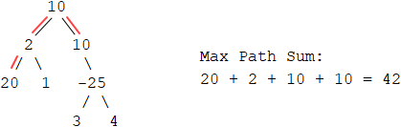

int findMax(Node* node, int &res)
{
if (node == NULL)
{
return 0;
}

int lc = findMax(node->left, res);
int rc = findMax(node->right, res);

int max_single = max(max(node->data + lc, node->data + rc), node->data);
res = max(max(node->data + lc + rc, max_single), res);

return max_single;
}

int findMaxSum(Node *root)
{
int res = INT_MIN;
findMax(root, res);
return res;
}

- Find the maximum path sum between two leaves of a binary tree.

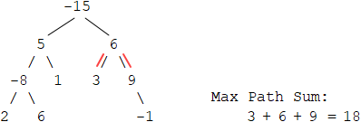

int findMaxPath(Node *node, int &res)
{
if (node == NULL)
{
return 0;
}

int lc = findMaxPath(node->left, res);
int rc = findMaxPath(node->right, res);

int max_single = max(node->data + lc, node->data + rc);
res = max(node->data + lc + rc, res);

return max_single;
}

int maxPathSum(Node *root)
{
int res = INT_MIN;
findMaxPath(root, res);
return res;
}

- Given a binary tree, print the longest path from the root to a leaf.

vector<int> height(Node *root)
{
if (root == NULL)
{
return vector<int>();
}

vector<int> v1 = height(root->left);
vector<int> v2 = height(root->right);

if (v1.size() < v2.size())
{
v2.push_back(root->data);
return v2;
}

v1.push_back(root->data);
return v1;
}

void longestPath(Node* root)
{
vector<int> v = height(root);

for (auto it = v.rbegin(); it != v.rend(); ++it)
{
printf("%d ", *it);
}
}

- Given a tree and a node, reverse the path from the root to the node.

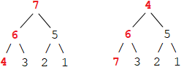

bool getPath(Node *root, int x, vector<Node*> &vec)
{
if (root == NULL)
{
return false;
}

if (root->data == x)
{
vec.push_back(root);
return true;
}

bool res = getPath(root->left, x, vec);
if (!res)
{
res = getPath(root->right, x, vec);
}

if (res)
{
vec.push_back(root);
}

return res;
}

void reversePath(Node *root, int x)
{
vector<Node*> vec;
getPath(root, x, vec);

for (int i = 0, j = vec.size() - 1; i < j; ++i, --j)
{
int tmp = vec[i]->data;
vec[i]->data = vec[j]->data;
vec[j]->data = tmp;
}
}

- Given a binary tree and an integer x, delete all the leaf nodes, including the newly formed leaves, having value as x.

Node *deleteUtil(Node *node, int x)
{
if (node == NULL)
{
return NULL;
}

node->left = deleteUtil(node->left, x);
node->right = deleteUtil(node->right, x);

if (node->left == NULL && node->right == NULL && node->data == x)
{
delete node;
return NULL;
}

return node;
}

- Given a binary tree and a number k, remove all nodes that lie only on paths whose length < k. Given the following tree and k = 4, only node 5 is removed because it is on a path {1, 2, 5} whose length is 3.

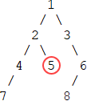

Node *removeNode(Node *root, int k, int level = 1)
{
if (root == NULL)
{
return NULL;
}

root->left = removeNode(root->left, k, level + 1);
root->right = removeNode(root->right, k, level + 1);

if (root->left == NULL && root->right == NULL && level < k)
{
delete root;
return NULL;
}

return root;
}

- Given a binary tree and a number k, print all the paths whose sum = k.

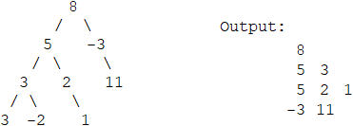

void printUtil(Node *root, vector<int> &vec, int k)
{
if (root == NULL)
{
return;
}

vec.push_back(root->data);

printUtil(root->left, vec, k);
printUtil(root->right, vec, k);

int sum = 0;
for (int i = vec.size() - 1; i >= 0; --i)
{
sum += vec[i];

if (sum == k)
{
for (int j = i; j < vec.size(); ++j)
{
printf("%d ", vec[j]);
}

printf("\n");
}
}

vec.pop_back();
}

void allPaths(Node *root, int k)
{
vector<int> vec;
printUtil(root, vec, k);
}

The following has better performance. If you use reference parameters, you need to roll back after the function calls.

void printPath(vector<int> &vec, int start)
{
for (int i = start; i < vec.size(); ++i)
{
printf("%d ", vec[i]);
}

printf("\n");
}

void allPaths(Node *root, int sum, int k, unordered_map<int, vector<int>> m, vector<int> vec)
{
if (root == NULL)
{
return;
}

vec.push_back(root->data);
sum += root->data;

if (m.find(sum - k) != m.end())
{
for (int i : m[sum - k])
{
printPath(vec, i + 1);
}
}

m[sum].push_back(vec.size() - 1); // remember the index

findPath(root->left, sum, k, m, vec);
findPath(root->right, sum, k, m, vec);
}

void allPaths(Node *root, int k)
{
unordered_map<int, vector<int>> m;
m[0].push_back(-1);

vector<int> vec;
allPaths(root, 0, k, m, vec);
}

- Given a binary tree and a number k, find the count of paths whose sum = k.

int countPaths(Node *root, int sum, int k, unordered_map<int, int> m)
{
if (root == NULL)
{
return 0;
}

sum += root->data;
int count = 0;

if (m.find(sum - k) != m.end())
{
count += m[sum - k];
}

m[sum]++;

count += countPath(root->left, sum, k, m);
count += countPath(root->right, sum, k, m);

return count;
}

int countPaths(Node *root, int k)
{
unordered_map<int, int> m;
m[0] = 1;

return countPath(root, 0, k, m);
}

